

**Quispamsis Middle School: Are you ready for a great trip?**

Spring is here and Bon Vivant Educational Tours wants to make sure that you are well prepared for your upcoming tour! That’s why we’ve put together this information sheet.

**Hotel Details**

**June 12th - 15th** : Holiday Inn Express, 3145 Ave des Hôtels, Québec, QC, 418-653-9321

**Tour Dates**

Departure: Wednesday, June 12th, 6:30 am. **Leaving from the school parking lot (please arrive by 6:00 am)**

Departure from Quebec City: Saturday, June 15th at 10:30 am

Estimated time of arrival in Quispamsis: Between 8:00 – 8:30 pm. Students will call/text when we’re approx. 20 minutes away. Please be on time!!! Our chaperones will have had a long 4 days with 100 energetic teens!!!

**Health Insurance**

Don’t forget to bring your **NB Medicare** card number with you on the tour.

**Emergency Contacts**

**24/7 Emergency Line (toll free): 1-855-575-0916**

You can also contact Bon Vivant by emailing us at: [**bonvivanttours@gmail.com**](mailto:bonvivanttours@gmail.com)

**School number: QMS 847-6210**

**Shawna Spinks (506) 653-7289 Please only contact in an emergency.**

**Tour Guide:**  Neil Schomaker [418-456-3415](tel:(418)%20456-3415)

**Bon Vivant Security bracelets**

Upon arrival in Québec, each child will receive a silicone bracelet with emergency numbers on it.

**Follow us!** [**Facebook**](https://www.facebook.com/BonVivantEducationalTours) **(Bon Vivant Educational Tours)** [**Twitter**](https://twitter.com/bon_vivant_tour) **(bon_vivant_tour) &** [**Instagram**](https://www.instagram.com/bon_vivant_tours/?hl=en) **(bon_vivant_tours)**

**Visit our website:** [**http://www.bonvivanteducationaltours.com/en/**](http://www.bonvivanteducationaltours.com/en/)

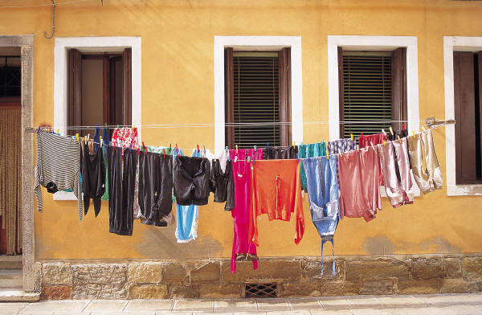

**Bon Vivant’s Packing List**

Here is a list of packing items that we’ve put together to help you prepare for the tour. We have also included a few tips that have helped students and teachers on previous tours!

**Packing Tips**

* Since you will be walking a lot, comfortable shoes are essential. Don’t break in new shoes on the trip!
* Make sure that your luggage is light enough so that you can carry it on your own.
* You may want to take a look at the weather forecast right before packing, so that you can plan accordingly.
* Shampoo, conditioner and soap will be available at your hotel. Not bringing your own can save space and weight.

**Items**

* Comfortable walking shoes (running shoes and or sandals)
* Long sleeve shirts and t-shirts
* Shorts, pants and jeans
* Bathing suit, flip flops and a beach towel for BORA Water Park
* PE clothing for Circus School
* 1 nicer outfit for the boat cruise
* Socks and underwear ☺
* Night wear
* Raincoat/wind breaker/small dollar store plastic rain poncho
* Compact umbrella (if there is forecast for lots of rain)
* Toothbrush and toothpaste
* Deodorant
* Hairbrush or comb
* Just-a-Drop ☺ It works, it really does!
* Sunscreen and sunglasses
* Hat
* Contact lenses and solution (if applicable)
* Soap and shampoo (unless you choose to use the ones provided by the hotel)
* Medication in original packaging
* Alarm clock / Watch
* Water bottle
* Small day pack to carry a sweater/umbrella, water bottle, etc.
* Camera with memory cards and battery charger or space on your camera roll on your phone. Delete before we go!
* Wallet, with a bit of cash and/or gift cards and/or a debit card *** It is strongly recommended that you set up a Debit Card **now** if you do not already have one. It takes several weeks for the card to arrive in the mail.
* Medicare card number
* Travel insurance (If applicable: company, policy number and phone number in case of emergency)
* Friends and family’s addresses in case you want to send them postcards while on tour